The Effects of Athletic Ability on NFL Success

## Jack Burdick 1 , Dr. Said Bettayeb 2

1 Department of Computer Science, University of Houston – Clear Lake, 2700 Bay Area Blvd, Houston, TX 77058

2 Department of Computer Science, University of Houston – Clear Lake, 2700 Bay Area Blvd, Houston, TX 77058

# Abstract

The NFL Draft is an annual event where young college prospects are chosen to join one of 32 professional football teams. Each team has a limited number of selections and must find the best players available in order to help their team succeed. Teams spend all year scouting college players, watching game film, and will ultimately use their athletic measurements to gauge their future potential. Even after all the careful consideration put forth in choosing, most players do not wind up playing in the NFL for more than 4 years. Using just a player’s athletic measurements, we look to see if any trends can be observed to help predict if a player will make an impact for their team.

## Introduction

Over 200 players are chosen to play professional football each year; Most of these players will not contribute to their teams in any meaningful way, regardless of the order they are chosen. This makes it incredibly important to be able to discern which players are worth picking, and which should be avoided. As it can be tough to decide what counts as a contribution to a team, we tested how someone’s athletic ability affects their chances of making a pro bowl in their career.

The main goal will be to find the likelihood of drafting a pro-bowler, decide whether there are any trends that determine if a player will be successful, and to examine which athletic measurements lead to more success. Due to positional differences, we will only be looking at running backs and receivers drafted from 2000 – 2010, as the success of these positions is largely dependent on their own skills. Through this study we hope to find a way to improve the grading of NFL draft prospects and ultimately increase the chances of drafting players that will be successful in the NFL.

## Tools

Throughout this project we exclusively used the Anaconda [1] package to write code in Python. Anaconda is an open-source distribution of Python that is widely used for scientific computing due to its package management system and wide array of tools. This project focused on writing code in the Spyder IDE [2] while using a variety of Python packages, to include NumPy [3], Pandas [4], and Matplotlib [5].

NumPy is a Python programming library that is often used when working with large arrays or matrices. It also allows an array of simplified mathematical functions that can be useful for computing and maintaining neat code. NumPy is used in this project to compute the slope of our scatter plots in order to find a trend.

Pandas is a Python library that can be used to access excel files more easily. This allows us to work with large data sets very easily and manipulate our data however we see fit. Pandas is used very heavily throughout this project to take in data and send it to our Matplotlib implementations.

Matplotlib is a coding library that can be used to show graphical representations of data. Without Matplotlib, we would have to use a variety of other general-purpose GUI to illustrate our data. Throughout this project, Matplotlib is used to illustrate all our graphs and create an easy to understand representation of our data sets.

## Methods

Using a set of NFL combine measurements for wide receivers and running backs dating from 2000-2010, we are going to analyze and compare the differences between players that were voted to a pro bowl at one point in their careers and the set of all players that attended the combine at their positions over the same time span. Using the Pandas library, we will load in the list of players and measurements obtained from *Pro Football Reference* [6] and run the data through three different measurements.

The first measurement will be to see how many players made a pro bowl that were drafted over a ten-year span. This will give us an idea of how small our pro-bowler data set is and let us see just how difficult it is to draft a pro bowl caliber player.

Out second measurement will convert four different datasets (running backs, pro bowl running backs, wide receivers, and pro bowl wide receivers) into boxplots so that we can easily compare the mean, maximum, minimum, and quartile measurements between pro bowl players and average players.

Our last measurement will look at what makes a pro bowl player even more successful by plotting the number of pro bowls a player made against their athletic measurements. Using a scatter plot, we will create a trendline to see which combine measurements led to a higher number of pro bowls over a player’s career.

## Measuring the Chance of Drafting a Pro-Bowler

To truly understand how difficult drafting a pro bowl caliber player is, we measured the number of players who attended a pro bowl over the course of 10 years. As you can see below, less than 10% of players drafted will attend a pro bowl. While drafting pro-bowlers isn’t the only goal of drafting NFL players, it does become more important when you realize the minimum salary for a rookie player is $480,000. Some rookies earn more than $10,000,000 a year, so getting a proper return on investment is crucial.

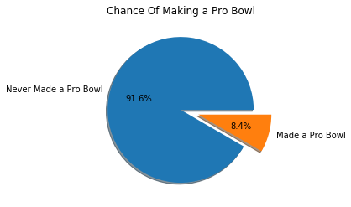

## Comparing Athletic Measurements

To illustrate the differences between an average player and an average pro bowl player, we have constructed a series of boxplots. This was accomplished using a combination of Matplotlib and Pandas in the Spyder IDE. Listed below are 7 different boxplots showing the distribution of measurements for each group across different athletic measurements.

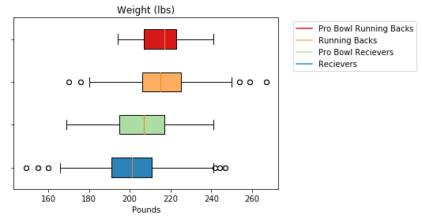

Our first measurement shows how an average player’s weight compares to a pro-bowler’s. The average pro bowl running back weighs about the same weight as an average college running back. When looking at the wide Receiver distribution though, we found that Pro Bowl receivers tend to weigh a bit heavier than an average receiver. Another observation is that the whisker for Pro Bowl Running Backs does not extend very far to the left, this implies that there is a low chance of an undersized running back making a pro bowl.

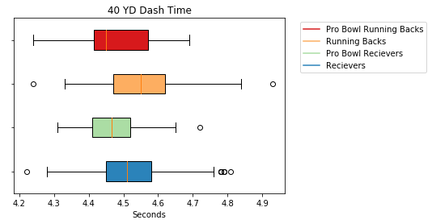

Our second measurement was the 40 yard dash. The 40 YD dash is typically used as a measurement to test a player’s acceleration and top-end speed. A good time in the 40 typically leads to a lot more demand for a player but does not necessarily mean they will succeed in the NFL. What we see in our graph above is that Pro Bowlers typically run faster than their counterparts, but an interesting finding is that there are no pro bowl receivers who ran under a 4.3 This is an interesting finding because many people get excited about times that are under 4.3 in the NFL Draft Combine, however our data shows that the fastest players do not necessarily become great wide receivers.

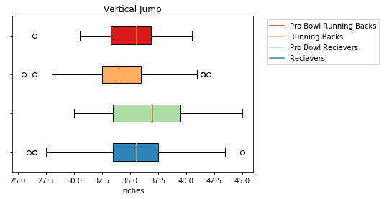

The Vertical Jump test is used to measure explosiveness and see how high a player can jump from a standstill. Our graph shows the average pro bowl player jumps higher than 75% of the players at their respective positions.

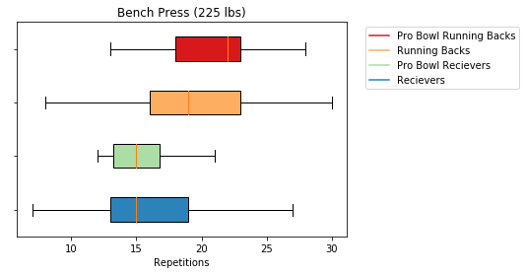

The Bench Press consists of players lifting 225 pounds as many times as they can without stopping. It is used to measure upper body strength but is not usually considered an important drill. Due to this, there is a very low sample size available, as most people decide to skip the bench press. Going off our limited data, we found that there is not much of a difference between receivers and pro receivers, however there is a big difference between the average pro bowl running back and regular running backs. This could possibly be attributed to the fact that running backs need to sustain more hits. Receivers do not typically take hits high on their bodies, but running backs are forced to run into defensive lineman, who are usually 6 inches taller than them, on a regular basis. Using this knowledge, we can infer that it might be important for running backs to have enough upper body strength to resist being tackled high on their bodies.

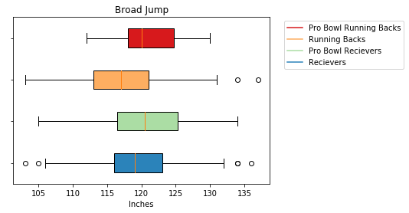

The broad jump test consists of players jumping as far forward as possible from a standing position. It is commonly used to test lower body explosiveness. While there is a small difference between pro bowl receivers and their counterparts, there is a much more pronounced difference between pro bowl running backs and their counterparts. This can possibly be attributed to the fact that explosiveness is derived from quick twitch muscles, which can also be used to make sudden movements common among running backs.

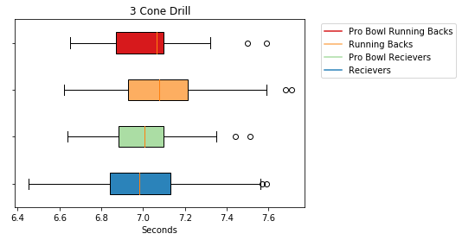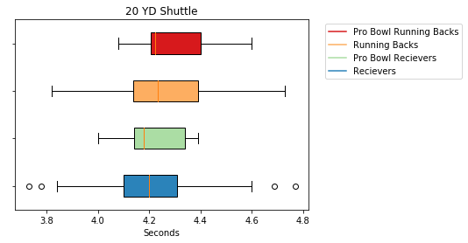

Our findings show that there is hardly any difference between pro-bowlers and average players when it came to the 20 YD Shuttle or the 3 Cone Drill.

## The Effect of Athletic Ability on Sustained Success

As one last search for trends on NFL success, we used a scatter plot to compare how many times someone attended the pro bowl with their athletic measurements.

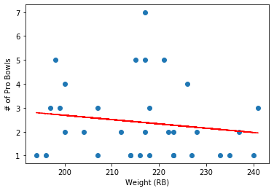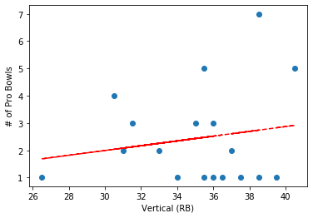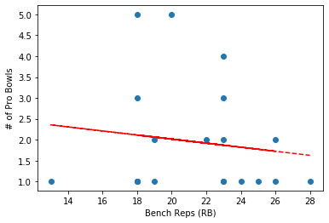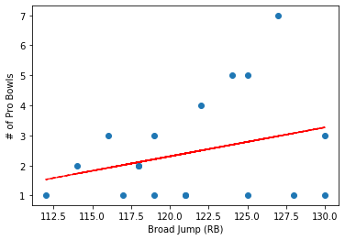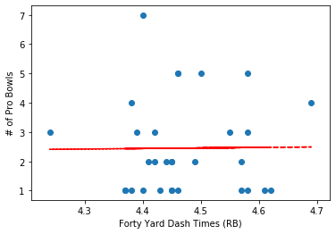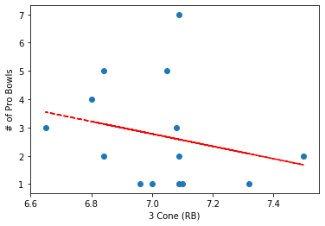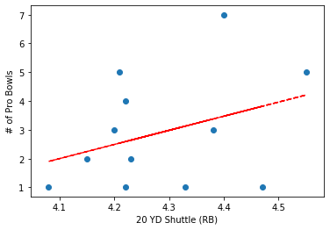Judging by this data, we can see that smaller, more athletic running backs tend to make more pro-bowlers than their heavier, stronger counterparts. This is interesting as some may think that a sturdier build would allow a better longevity and let running backs take more punishment before breaking down. Our data shows the opposite though, and that perhaps it is more important to avoid being hit altogether than to be able to stand up to multiple hits over the course of a career. Another interesting find is that the 3 Cone Drill had the biggest impact on the amount of pro bowls a player made over their career. We would need more data to form a concrete hypothesis about the importance of the 3 Cone Drill for running backs, but it would be an interesting idea to explore.

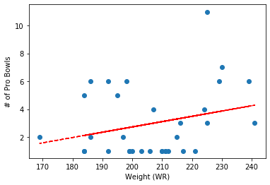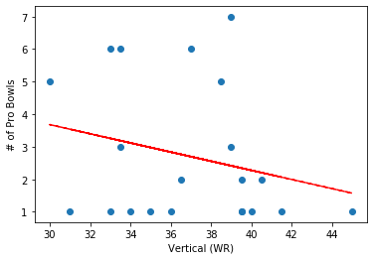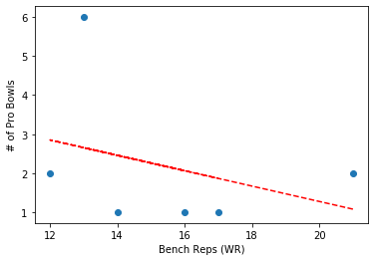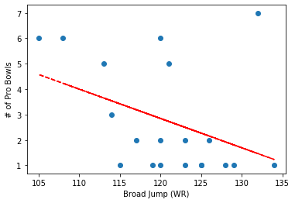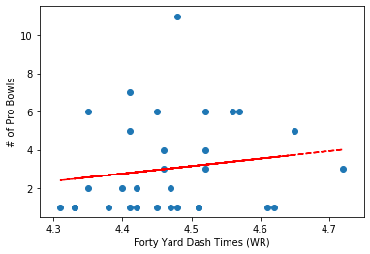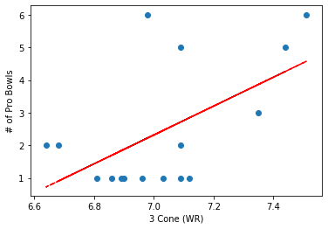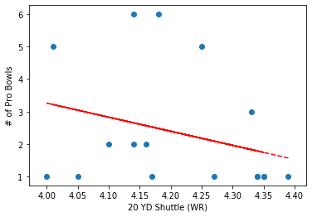

As opposed to our running back trends, our wide receiver trends show that slower, heavier wide receivers make more pro bowls over the course of their careers. This is incredibly interesting, as many receivers are expected to be the fastest players on their teams, but our findings show that maybe it is better to sacrifice athleticism for a sturdier build. Across all of our metrics, except one, the trend tends to favor less athleticism.

## Conclusion

By studying seven different athletic measurements for running backs and receivers we have been able to find a few trends that may lead to better drafts for NFL teams. When looking at running back measurements, it is more important to find the most athletic player you can, and not worry about weight, so long as they are at least 200 pounds. This helps them sustain hits in the NFL while also being able to avoid being hit too much. For receivers, it is a bit trickier; to be successful they need to be more athletic than the average receiver, but they also need to carry more weight than other receivers. True superstar receivers tend to be less athletic than other pro bowl receivers, but have heavier, stronger builds in order to hold up to NFL punishments. This is a bit of a widely known idea though, as outside receivers, who tend to be bigger and stronger, are valued more than slot receivers, who tend to be smaller and quicker.

When it comes to the importance of specific drills, running backs can be judged primarily on drills that test quick-twitch muscles such as the Vertical Jump and Broad Jump. Receivers tend to need a healthy balance between slow-twitch and fast-twitch muscles. This can be shown in our scatter plots as the 20 YD Shuttle time had the biggest impact on the amount of pro bowls a player made in their career.

In the future it would be worth looking into the how other positions compare to their pro bowl counterparts or to look at how quick twitch muscle growth affects the success of running backs. We could also take a closer look at the importance of each drill to classify which measurements are more important that others. If we had more data, we could look at players who become useful to their team in other ways than making a pro bowl.

## References

[1] <https://www.anaconda.com/>

[2] <https://www.spyder-ide.org/>

[3] <https://numpy.org/>

[4] <https://pandas.pydata.org/>

[5] <https://matplotlib.org/>

[6] <https://www.pro-football-reference.com/>

## Works Cited

“NFL Combine Results.” *Pro*, www.pro-football-reference.com/play-index/nfl-combine-results.cgi.

“Overview.” *Overview - Matplotlib 3.3.0 Documentation*, matplotlib.org/contents.html.

“Pandas Documentation.” *Pandas Documentation - Pandas 1.1.0 Documentation*, pandas.pydata.org/docs/.

“How Can I Draw Scatter Trend Line on Matplot? Python-Pandas.” *Stack Overflow*, 1 July 2017, stackoverflow.com/questions/41635448/how-can-i-draw-scatter-trend-line-on-matplot-python-pandas/41635626.